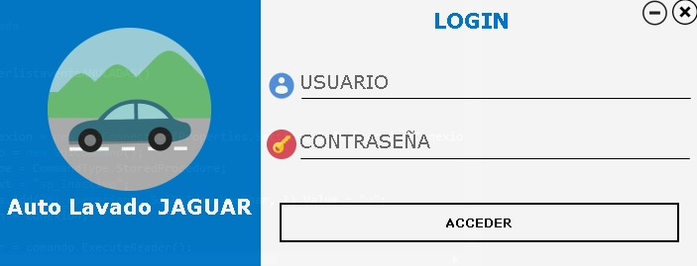

|  |  |  |  |
| --- | --- | --- | --- |
| Formulario_Login | | | |
| Componentes | Funciona correctamente | No funciona correctamente | Detalle de errores |
| Btn acceder | ✓ |  |  |
| Btn minimizar | ✓ |  |  |
| Btn cerrar | ✓ |  |  |
| Textbox user | ✓ |  |  |
| Textbox password | ✓ |  |  |

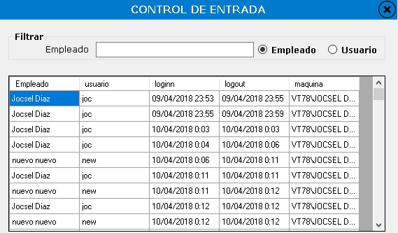

|  |  |  |  |
| --- | --- | --- | --- |
| Formulario Control de Entrada | | | |
| Componentes | Funciona correctamente | No funciona correctamente | Detalles de errores |
| Textbox Empleado | ✓ |  |  |
| RadioButoon Empleado | ✓ |  |  |
| Radiobutton usuario | ✓ |  |  |
| Button Cerrar | ✓ |  |  |

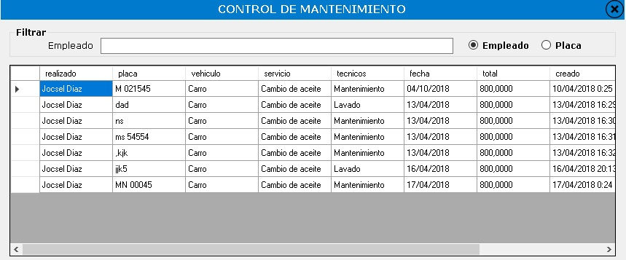

|  |  |  |  |
| --- | --- | --- | --- |
| Formulario control de Mantenimiento | | | |
| Componentes | Funciona correctamente | No funciona correctamente | Detalles de errores |
| Textbox empleado text changed | ✓ |  |  |
| Radio button empleado | ✓ |  |  |
| Radio button placa | ✓ |  |  |
| Text box nombre text changed | ✓ |  |  |
| Button cerrar | ✓ |  |  |

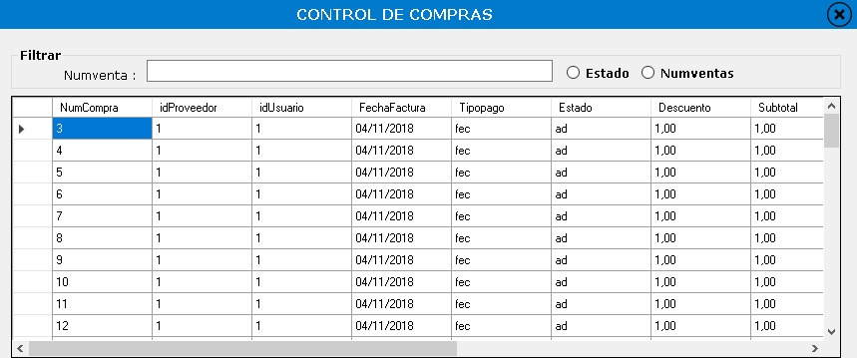

|  |  |  |  |
| --- | --- | --- | --- |
| Formulario de control de compras | | | |
| Componentes | Funciona correctamente | No funciona correctamente | Detalles de errores |
| Textbox estado text changed | ✓ |  |  |
| Radio button estado | ✓ |  |  |
| Radio numventas placa | ✓ |  |  |
| Text box numventas text changed | ✓ |  |  |
| Button cerrar | ✓ |  |  |

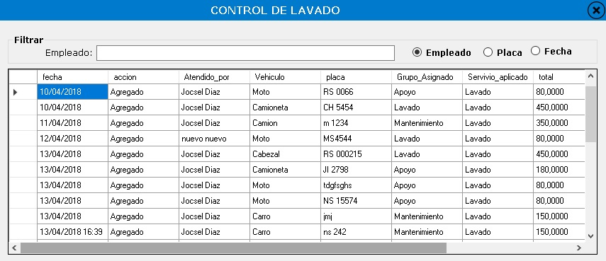

|  |  |  |  |
| --- | --- | --- | --- |
| Formulario Control de lavado | | | |
| Componentes | Funciona correctamente | No funciona correctamente | Detalles de errores |
| Textbox empleado text changed | ✓ |  |  |
| Radio empleado estado | ✓ |  |  |
| Radio button placa | ✓ |  |  |
| Text box placa text changed | ✓ |  |  |
| Button cerrar | ✓ |  |  |
| Textbox fecha text changed | ✓ |  |  |
| Radio button fecha | ✓ |  |  |

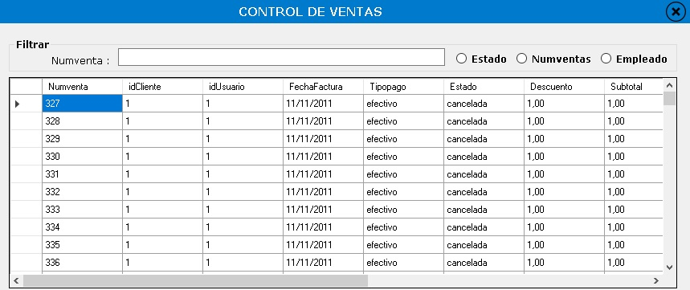

|  |  |  |  |
| --- | --- | --- | --- |
| Formulario Control de lavado | | | |
| Componentes | Funciona correctamente | No funciona correctamente | Detalles de errores |
| Textbox estado text changed | ✓ |  |  |
| Radio estado estado | ✓ |  |  |
| Radio numventas placa | ✓ |  |  |
| Text box numventas text changed | ✓ |  |  |
| Button cerrar | ✓ |  |  |
| Textbox empleado text changed | ✓ |  |  |
| Radio button empleado | ✓ |  |  |